* Online Movie Rating Website

1. A Convert this data model to a database design. Specify tables, primary keys, and foreign keys.

This database design was drawn using the MySQL Workbench. Note that primary keys (gold key symbol), foreign keys (red diamond), NULL status (white diamond is NULL, blue diamond is NOT NULL), and data types are shown. Maximum and minimum cardinalities and identifying or nonidentifying relationships are also indicated in the diagram.

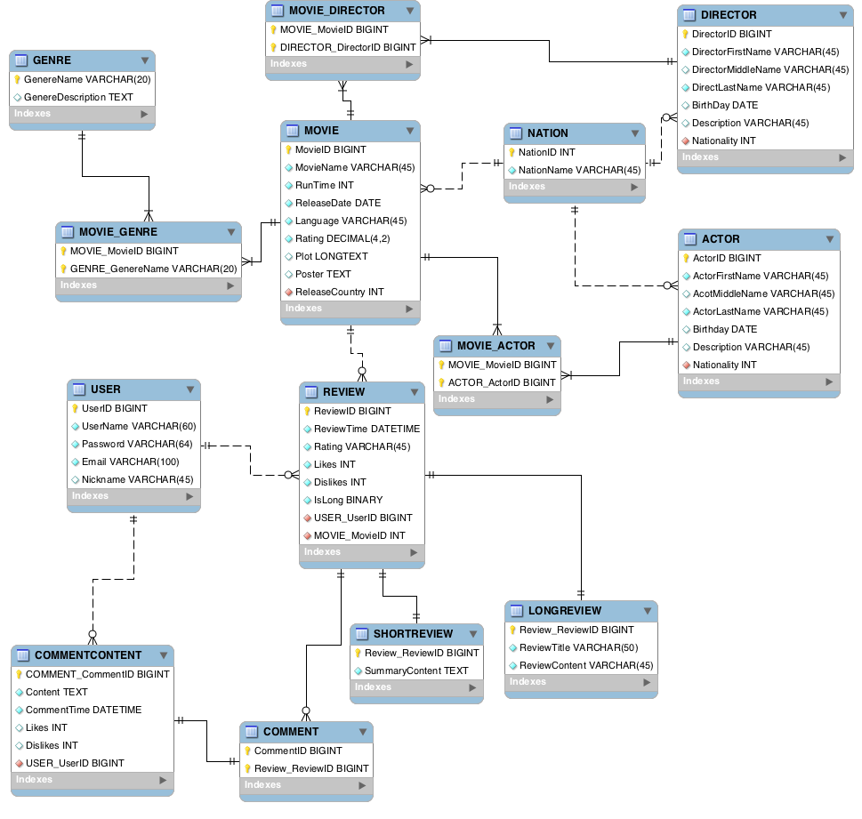

The E-R Crow’s Foot model above is based on the following data:

All N:M relationships are transformed to be intersection table in the graph above.

|  |  |  |  |  |
| --- | --- | --- | --- | --- |
| **RELATIONSHIP** | | | **CARDINALITY**  **[Blue = Inferable]** | |
| **PARENT** | **CHILD** | **TYPE** | **MAX** | **MIN** |
| MOVIE | GENRE | Weak | N:M | M-M |
| MOVIE | DIRECTOR | Weak | N:M | O-M |
| MOVIE | ACTOR | Weak | N:M | O-M |
| NATION | MOVIE | Strong | 1:N | M-O |
| NATION | DIRECTOR | Strong | 1:N | M-O |
| NATION | ACTOR | Strong | 1:N | M-O |
| REVIEW | SHORTREVIEW | ID-Dependent | 1:1 | M-M |
| REVIEW | LONGREVIEW | ID-Dependent | 1:1 | M-M |
| USER | REVIEW | Strong | 1:N | M-O |
| MOVIE | REVIEW | Strong | 1:N | M-O |
| USER | COMMENT | Strong | 1:N | M-O |
| REVIEW | COMMENT | Weak | 1:N | M-O |

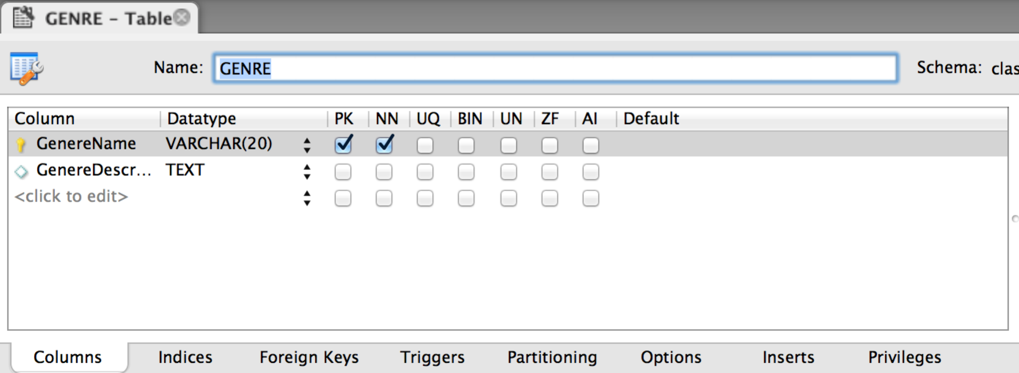

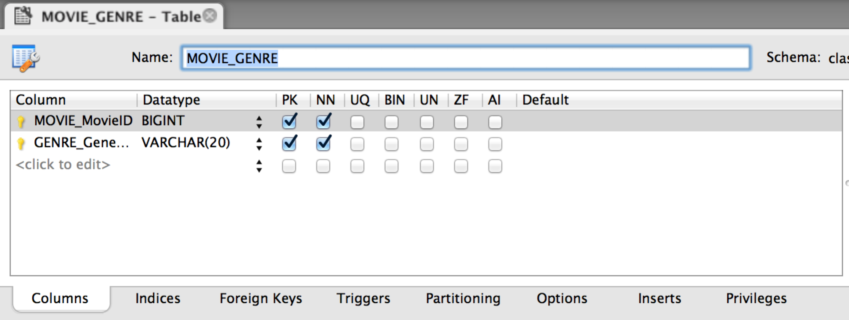

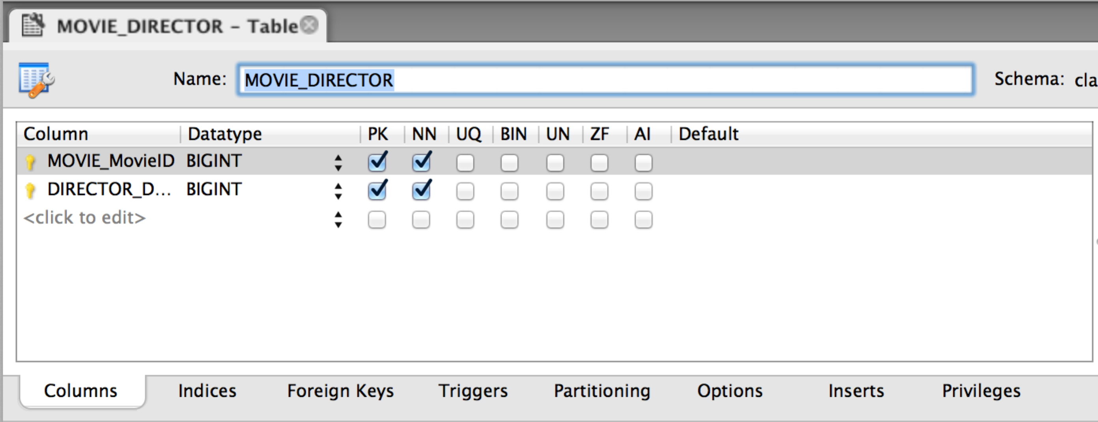

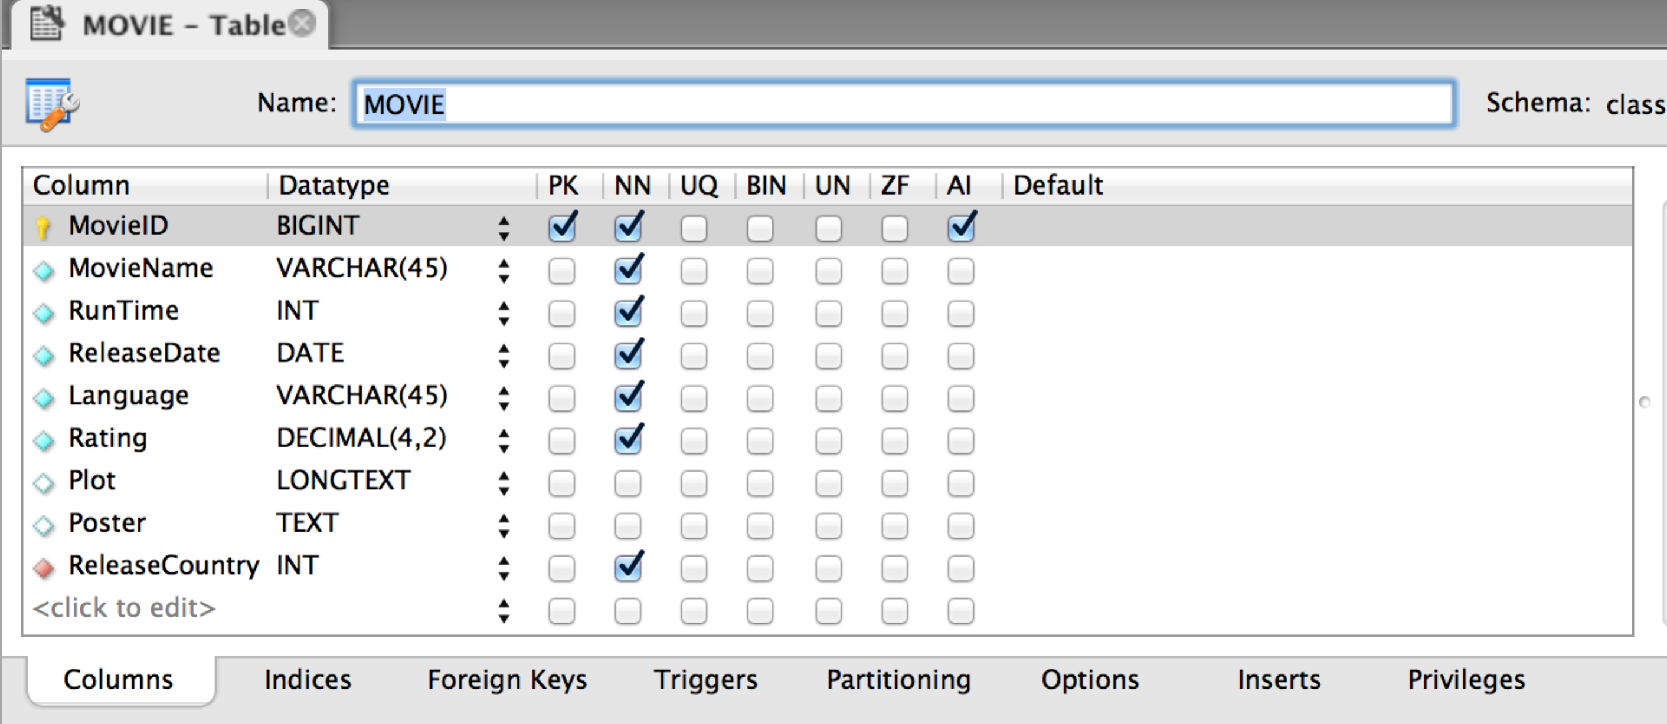

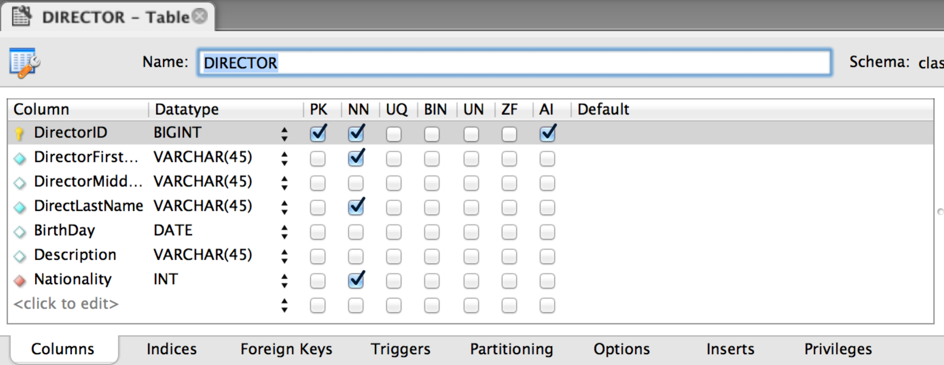

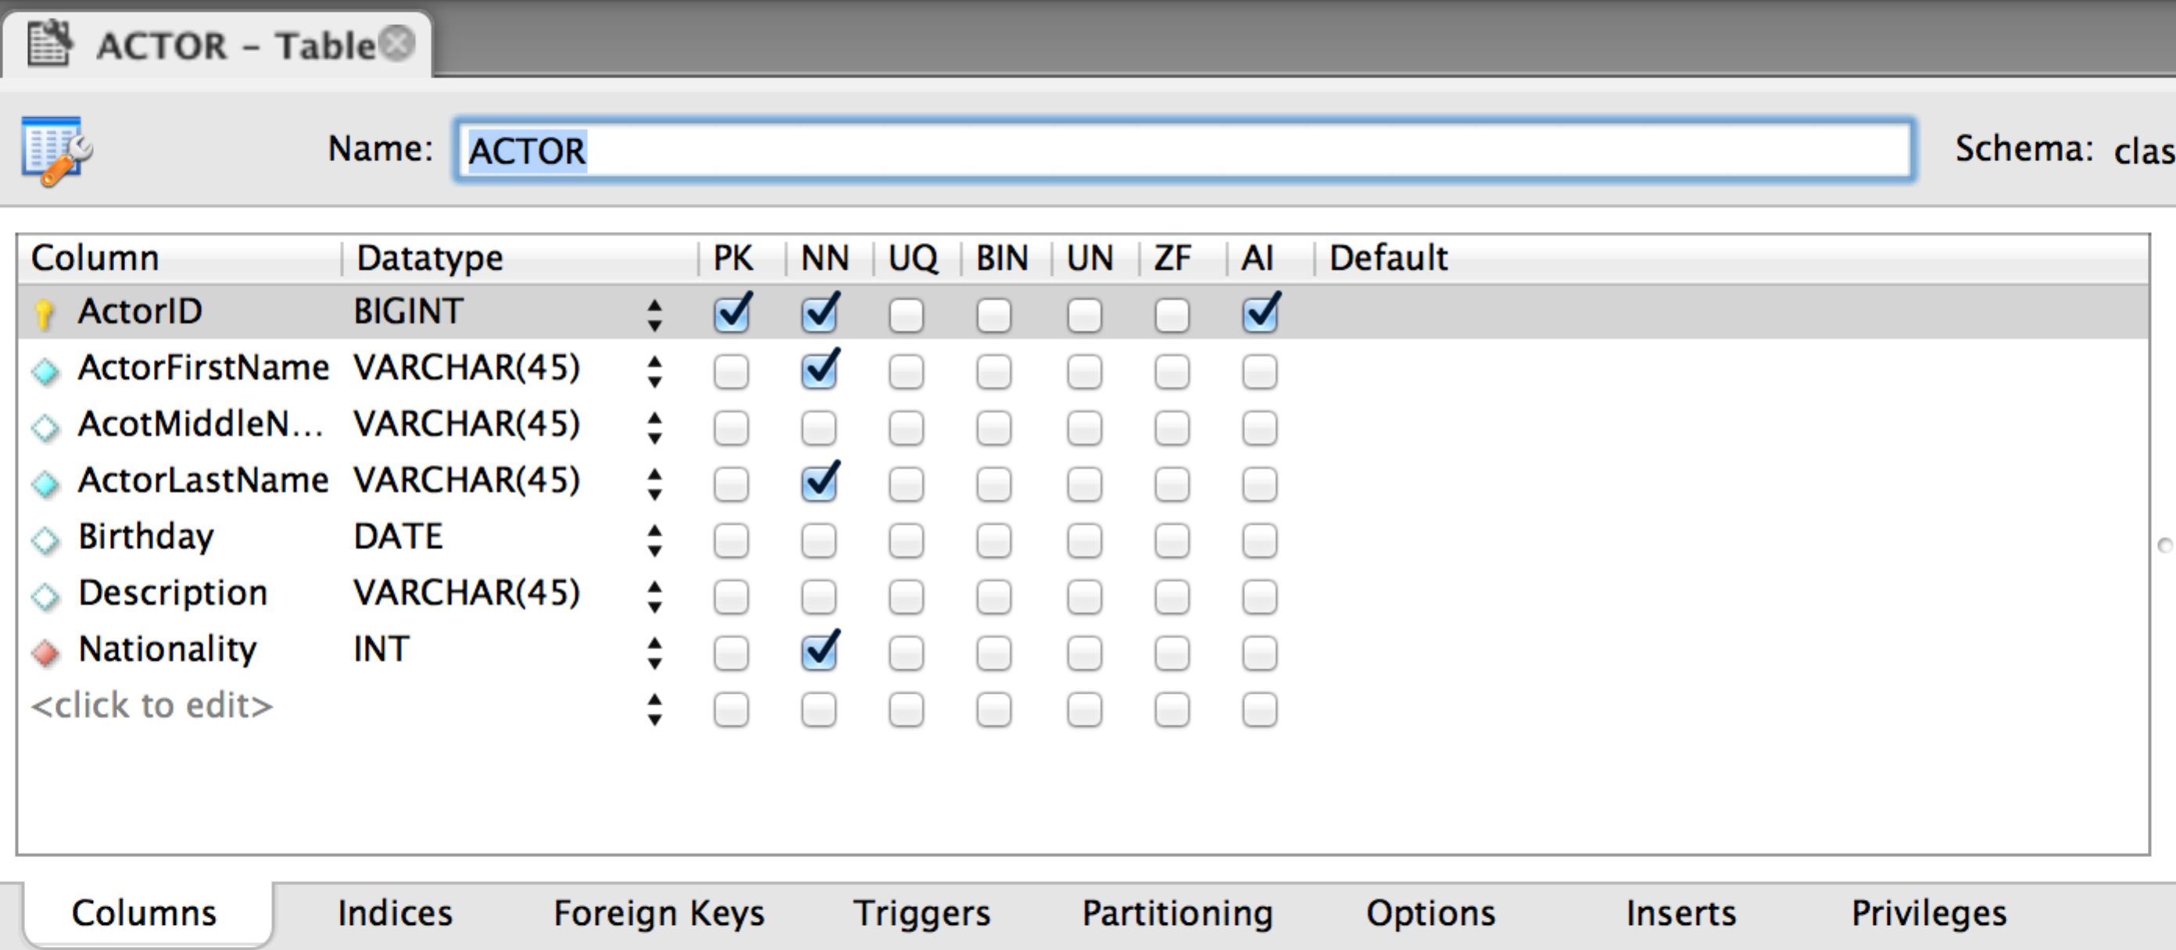

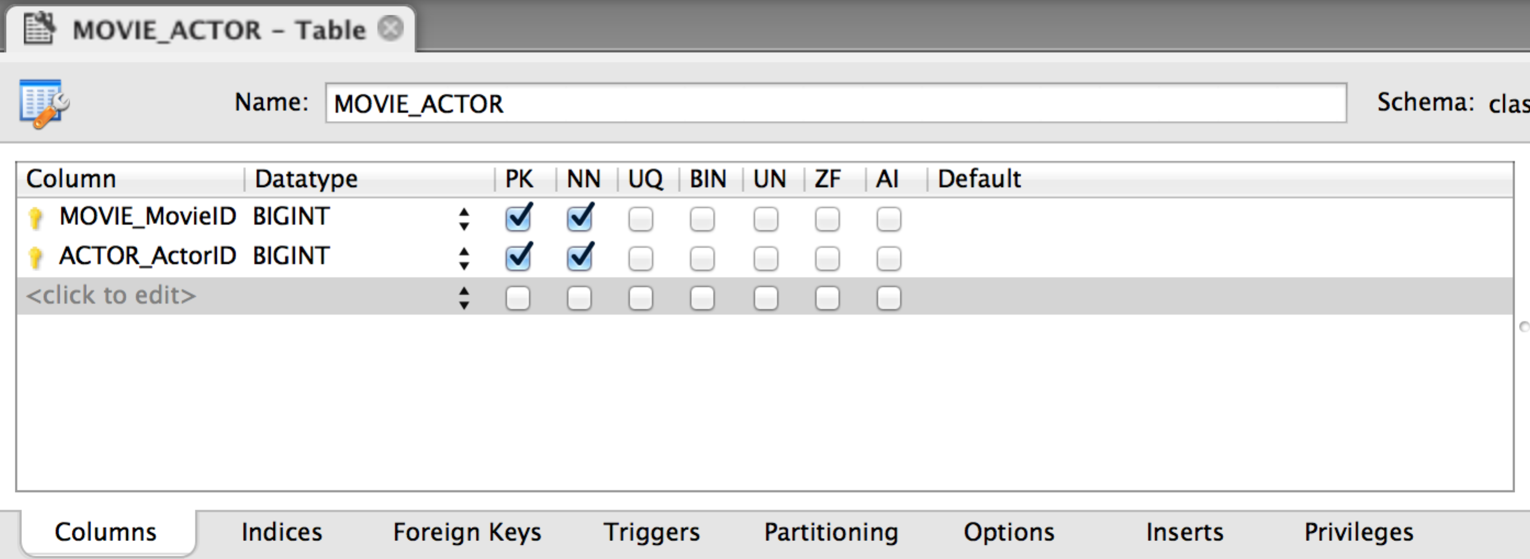

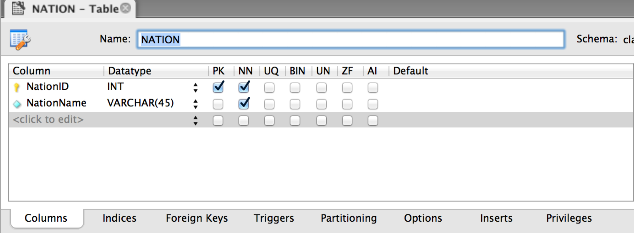

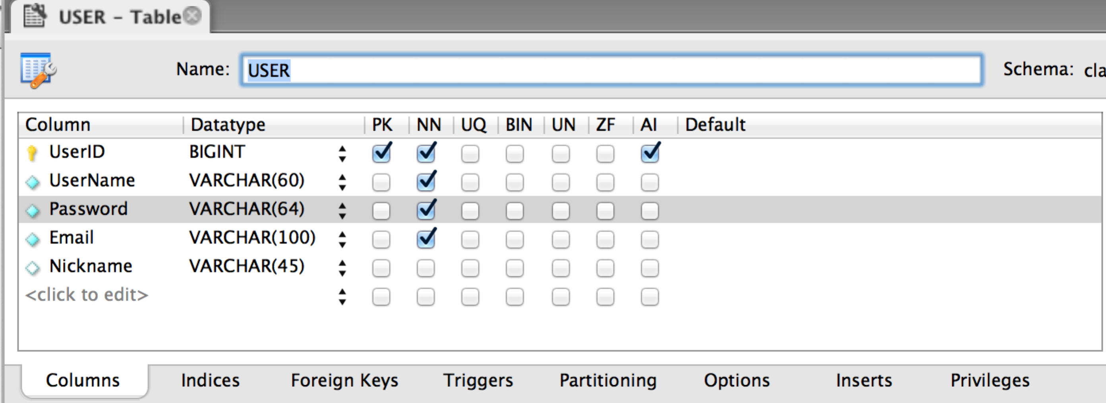

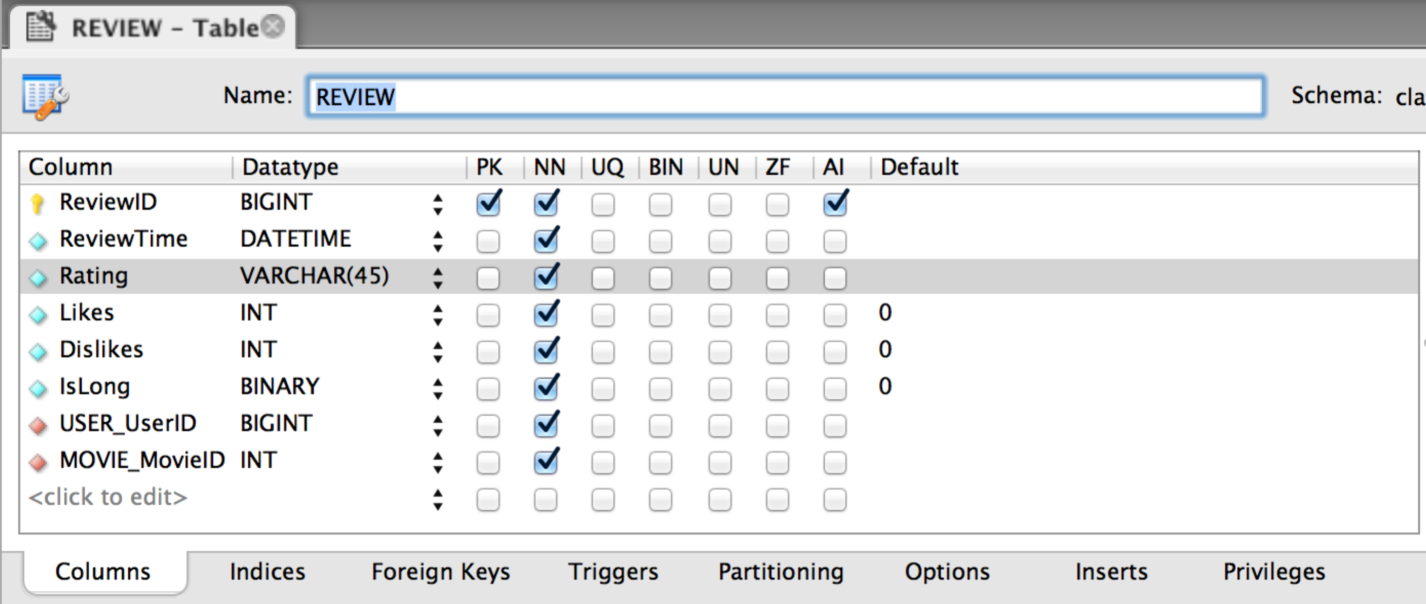

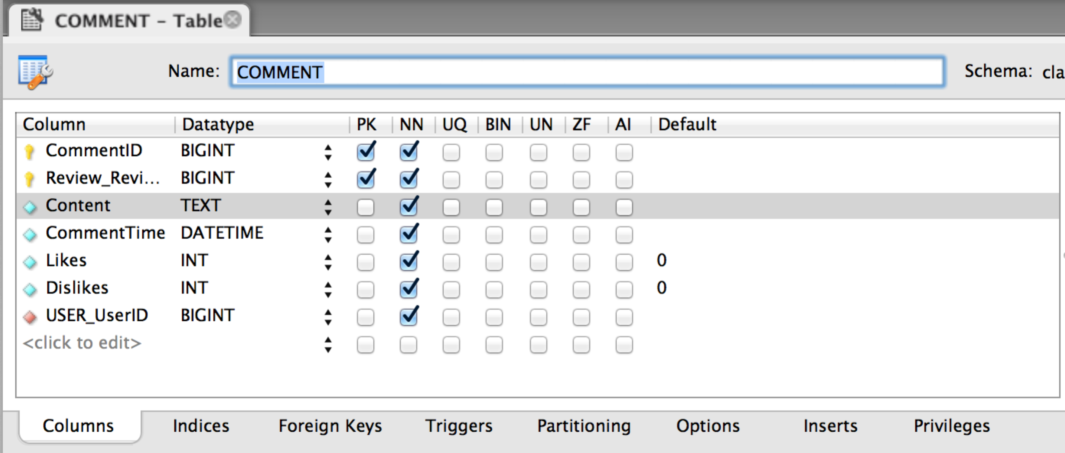

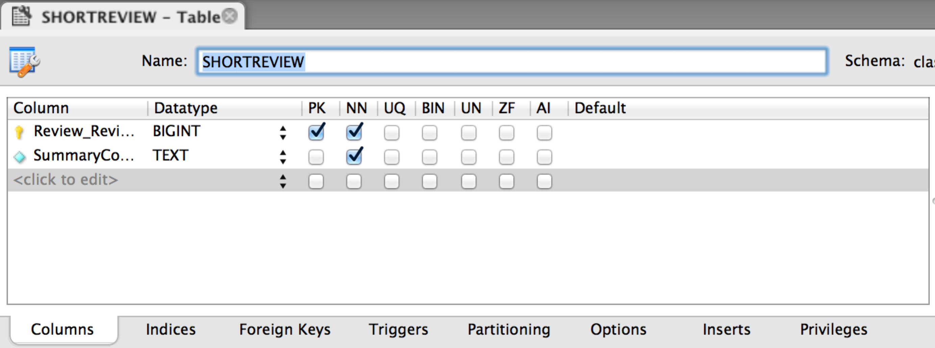

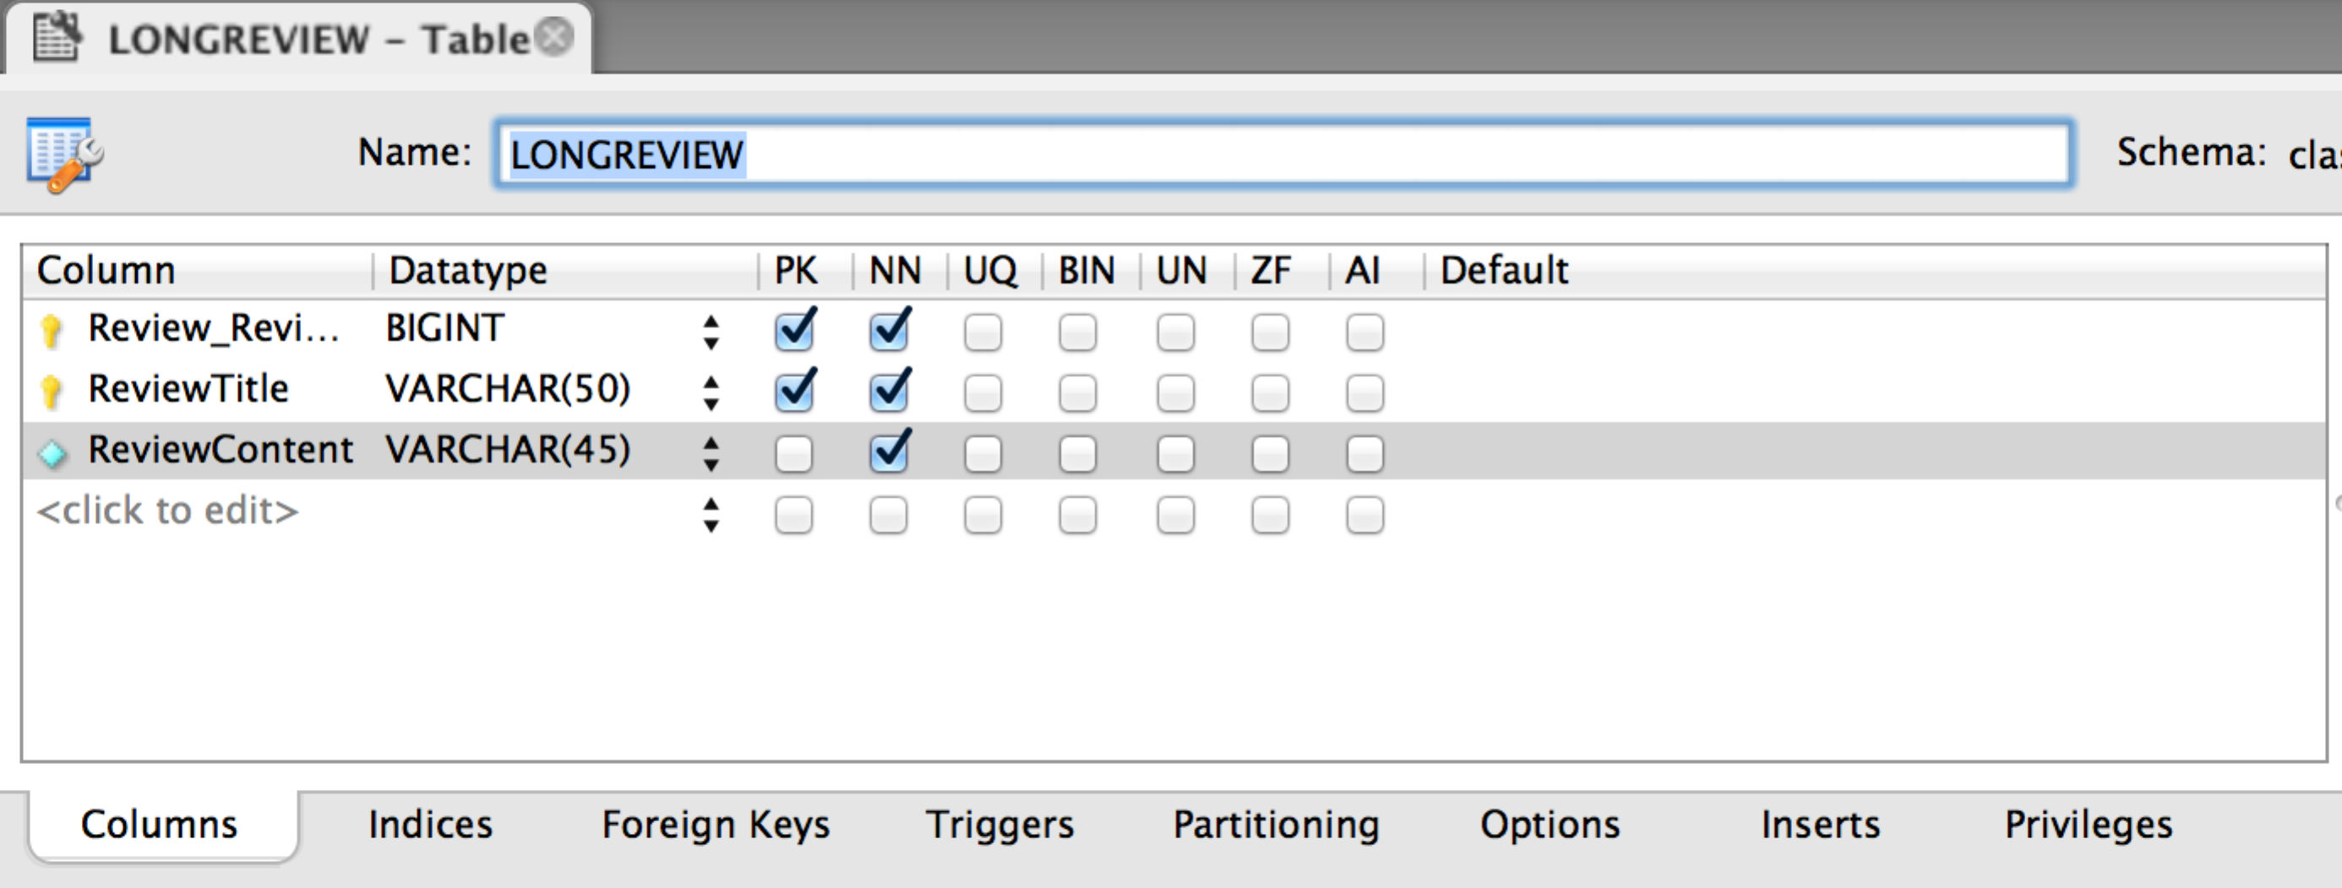

1. Describe how you have represented weak entities, if any exist.
2. COMMENT is ID-dependent on REVIEW.
3. The MOVIE_GENRE, MOVIE_ACTOR, MOVIE_DIRECTOR are weak entities
4. SHORTREVIEW and LONGREVIEW is id-dependent on Review
5. Describe how you have represented supertype and subtype entities, if any exist.

1) SHORTREVIEW is subtype of REVIEW.

2) LONGREVIEW is subtype of REVIEW.

1. Create a visual representation of your database design as a Crow’s Foot E-R diagram similar to the one in Figure 6-37.

See the E-R diagram for part A above.

1. Document your minimum cardinality enforcement using referential integrity actions for required parents, if any, and the form in Figure 6-28(b) for required children, if any.

|  |  |  |  |  |
| --- | --- | --- | --- | --- |
| **Relationship** | | **Referential Integrity Constraint** | **Cascading Behavior** | |
| **PARENT** | **CHILD** |  | **ON UPDATE** | **ON DELETE** |
| GENRE | MOVIE_GENRE | GENRE_Genrename in MOVIE_GENRE must exist in GenreName in GENRE | NO | YES |
| MOVIE | MOVIE_GENRE | MOVIE_MovieID in MOVIE_GENRE must exist in MovieID in MOVIE | NO | YES |
| DIRECTOR | MOVIE_DIRECTOR | DIRECTOR_DirectorID in MOVIE_DIRECTOR must exist in DirectorID in DIRECTOR | NO | YES |
| MOVIE | MOVIE_DIRECTOR | MOVIE_MovieID in MOVIE_DIRECTOR must exist in MovieID in MOVIE | NO | YES |
| ACTOR | MOVIE_ACTOR | ACTOR_ActorID in MOVIE_ACTOR must exist in ActorID in ACTOR | NO | YES |
| MOVIE | MOVIE_ACTOR | MOVIE_MovieID in MOVIE_ACTOR must exist in MovieID in MOVIE | NO | YES |
| NATION | MOVIE | ReleaseCountry in MOVIE must exist in NationID in NATION | YES | NO |
| NATION | ACTOR | Nationality in Actor must exist in NationID in NATION | YES | NO |
| NATION | DIRECTOR | Nationality in DIRECTOR must exist in NationID in NATION | YES | NO |
| MOVIE | REVIEW | MOVIE_MovieID in REVIEW must exist in MovieID in MOVIE | NO | NO |
| USER | REVIEW | USER_UserID in REVIEW must exsit in UserID in USER | NO | NO |
| REVIEW | SHORTREVIEW | REVIEW_ReviewID in SHORTREVIEW must exist in ReviewID in REVIEW | YES | YES |
| REVIEW | LONGREVIEW | REVIEW_ReviewID in LONGREVIEW must exist in ReviewID in LONGREVIE | YES | YES |
| USER | COMMENT | USER_UserID in COMMENT must exist in UserID in USER | YES | NO |
| REVIEW | COMMENT | REVIEW_ReviewID in COMMENT must exist in ReviewID in REVIEW | YES | YES |